**The main characters:**

**Macbeth** – a Scottish nobleman and soldier. At the beginning of the play, he is Thane of Glamis. He is ambitious, strong, and ruthless. After the witches’ prophecies, he is named Thane of Cawdor and then murders King Duncan to become King.

**Lady Macbeth** – Macbeth's wife. She is also ambitious and ruthless. She encourages/persuades Macbeth to commit the murders in the play but eventually goes mad with guilt and takes her own life.

**Duncan** – the King of Scotland. He is murdered by Macbeth at the beginning of Act II.

**Banquo** – Macbeth's friend and fellow nobleman and soldier. The witches prophesize that although Macbeth will be King, it will be Banquo’s heirs that will inherit the throne. Fearing this part of the prophecy, Macbeth has him killed.

**Macduff** – another nobleman and soldier of Scotland. Throughout the play he distrusts Macbeth and is the one to eventually kill him.

**Malcolm** – Duncan's son. He flees the country after his father’s murder. He becomes King at the end of the play.

**Lady Macduff** – Macduff's wife. Macbeth orders her murder, as well as the murder of her children.

**The witches** – three supernatural beings who have the gift of prophecy. They set the play in motion and drive the plot with their predictions.

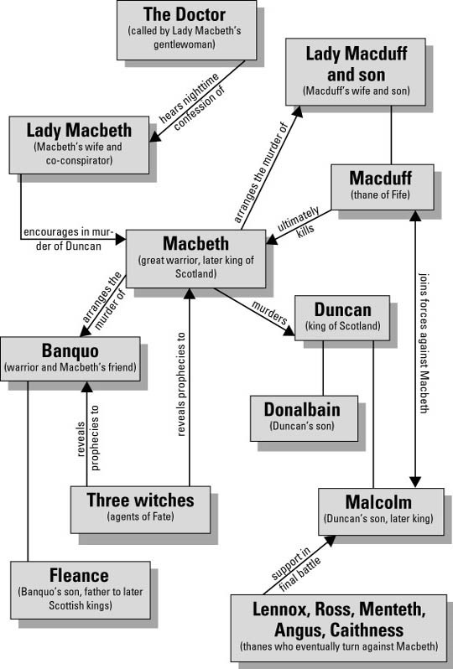

**PAIRS Character Maps:**

**Macbeth:**

* Physical Appearance:
* Actions:
* Inner Thoughts:
* Reactions:
* Speech:

**Macduff:**

* Physical Appearance:
* Actions:
* Inner Thoughts:
* Reactions:
* Speech:

As you respond to and analyse the play in this unit think about how all characters are constructed. Consider their actions, dialogue, interactions and relationships with other characters, including what other characters say about them, and most importantly, their asides and soliloquies where we get a glimpse of the character’s inner thoughts and conscience.

How has Macbeth’s ambition developed and expanded from Act 1, Scene 3 to Scene 7? Give examples from the text in your answer.

* Macbeth in Act 1 Scene 3:  
  “My thought, whose murder yet is but fantastical,  
  Shakes so my single state of man  
  That function is smothered in surmise,  
  And nothing is but what is not.”
* Macbeth in Act 1 Scene 7:

How are we invited to empathise with what Macbeth is experiencing in these passages? What attitudes, values and beliefs are inferred?